Computer Networks-CSA0707

ASSIGNMENT 1

PRAVEEN NK
1925260013

TASK 1 – Size the Traffic Before Choosing Anything
Bloom’s Level: K5 – Evaluate
One production line generates the following traffic:
Source | Quantity | Traffic
Robot controllers | 40 | 200-byte command every 2 ms each
Vibration sensors | 600 | 50 bytes per second each
CCTV cameras | 24 | 4 Mbps each (continuous)
Office users | 150 | 2 Mbps each at peak, 10% active at a time

Work out:
- The total traffic of one line in Mbps, and of the plant if there are 8 lines
- Which source sends the most data and which has the strictest delay requirement – are they the same?
- Whether a single 1 Gbps uplink from the shop floor is enough, and what happens to robot commands if the CCTV traffic shares the same queue
- A ranking of the traffic types by how harmful a 100 ms delay would be, with a reason for each
Solution:
Aim:
To calculate the traffic generated by each device group and determine whether the uplink has sufficient capacity.

Objectives:
1.Calculate traffic in Mbps for one production line and eight lines.
2. Compare data volume with delay sensitivity. (3) Evaluate the 1 Gbps uplink and the effect of reducing continuous CCTV traffic.

Calculations and Analysis
Robot controllers: Each controller sends 200 bytes every 2 ms. Rate per controller = (200 × 8) / 0.002 = 800,000 bit/s = 0.8 Mbps. For 40 controllers: 40 × 0.8 = 32 Mbps.
Vibration sensors: 600 × 50 bytes/s × 8 = 240,000 bit/s = 0.24 Mbps.
CCTV: 24 × 4 Mbps = 96 Mbps.
Office users: 10% of 150 users = 15 active users. Peak traffic = 15 × 2 Mbps = 30 Mbps.
Total per line = 32 + 0.24 + 96 + 30 = 158.24 Mbps. For 8 lines = 8 × 158.24 = 1,265.92 Mbps (about 1.266 Gbps). Therefore, a single 1 Gbps uplink is insufficient for the full eight-line plant.
CCTV sends the most data (96 Mbps), while robot commands have the strictest delay requirement (10 ms). They are not the same. If CCTV shares a congested FIFO queue, large video packets can delay small robot commands; use traffic prioritisation/QoS and separate industrial traffic.
100 ms delay harm ranking: (1) robot commands—deadline is 10 ms, so 100 ms is unacceptable; (2) AGV/control traffic—late commands can disrupt movement; (3) live CCTV—causes visible lag; (4) vibration telemetry—may reduce real-time fault detection; (5) office ERP/e-mail—usually tolerates delay better.

Alternative Concept Analysis
If CCTV records locally and sends motion-triggered clips only 5% of the time, CCTV traffic becomes 96 × 0.05 = 4.8 Mbps. New line total = 32 + 0.24 + 4.8 + 30 = 67.04 Mbps. Eight-line total = 536.32 Mbps. Under this assumption, a 1 Gbps uplink is adequate for the calculated average traffic, though engineering headroom and peak bursts should still be allowed.

Result: One line needs 158.24 Mbps; eight lines need 1,265.92 Mbps. Local CCTV recording reduces the estimate to 536.32 Mbps for eight lines and removes the 1 Gbps bottleneck under the stated assumptions.

TASK 2 – Count the Domains in the Contractor’s Drawing
Bloom’s Level: K5 – Evaluate
The contractor’s drawing for the office block shows: three hubs with 8 PCs each, all three hubs connected to one 24-port switch, the switch connected to router interface G0/0, and router interface G0/1 connected to a second switch with 12 IP phones.
Work out:
- The number of collision domains and broadcast domains, with a marked drawing
- The OSI layer at which each device works, and why a hub cannot stop collisions
- Which connections are point-to-point and which are multipoint
- Which standard and which body defines each of: Ethernet (IEEE 802.3), Wi-Fi (IEEE 802.11), IPv4 (IETF RFC 791), the OSI model (ISO 7498), and 5G (3GPP/ITU) – and why the plant should buy only standard-compliant equipment
Solution:

Aim:
To identify collision domains, broadcast domains, device layers, connection types and relevant standards.

Objectives:
Count domains in the hub-and-switch design, explain the role of hubs and switches, and evaluate replacing hubs with switches.
Analysis:
Original design: each of the three hubs and the devices attached to it share one collision domain, giving 3. The switch-to-router G0/0 link is 1 domain; router G0/1-to-second-switch is 1; and the 12 separate IP-phone switch ports are 12. Total collision domains = 3 + 1 + 1 + 12 = 17. The router separates the two IP networks, so there are 2 broadcast domains (one on each router interface).
Marked logical drawing: [8 PCs]—Hub 1—┐; [8 PCs]—Hub 2—├—24-port switch—Router G0/0 | Router G0/1—Switch—12 IP phones; [8 PCs]—Hub 3—┘. Broadcast domain A is on G0/0; broadcast domain B is on G0/1.
Device layers: Hub—OSI Layer 1 (repeats electrical signals and does not learn addresses); switch—Layer 2 (forwards frames using MAC addresses and gives each switch port a separate collision domain); router—Layer 3 (routes IP packets and separates broadcast domains); IP phone—application/upper-layer endpoint with Ethernet Layer 2 and IP Layer 3 functions.
A hub cannot stop collisions because all ports share one half-duplex collision domain. Point-to-point links include each hub uplink, switch-router links and each phone-to-switch link. A hub’s shared medium among its connected PCs is multipoint.

Standards table:
Ethernet—IEEE 802.3, IEEE; Wi-Fi—IEEE 802.11, IEEE; IPv4—RFC 791, published by IETF; OSI reference model—ISO 7498, ISO; 5G—3GPP specifications, with ITU defining IMT requirements. Standards-compliant equipment improves interoperability, supportability and predictable behaviour.

Result:
The original design has 17 collision domains and 2 broadcast domains. Replacing hubs with switches reduces collisions on shared access segments, but it does not reduce broadcast domains.

TASK 3 – Read a Captured Frame Layer by Layer
Bloom’s Level: K5 – Evaluate
A capture of one robot command shows the following fields:
Ethernet II Dst: 00:1d:9c:c7:b0:41 Src: 3c:52:82:4e:11:07 Type: 0x0800
IPv4 Src: 10.10.1.25 Dst: 10.10.9.4 TTL: 61 Protocol: 6 (TCP)
TCP Src Port: 51522 Dst Port: 502 (Modbus) Seq: 1201 Ack: 88 Len: 12
Data 12 bytes (Modbus write-register command)

Work out:
- The OSI layer and the protocol data unit (frame, packet, segment, data) of each line
- How many routers the packet crossed if the controller sets TTL to 64
- The total bytes on the wire (include the 4-byte FCS) and the percentage that is overhead; then repeat for a 1,400-byte camera packet – what does this tell you about small commands?
- Which layer is responsible when (a) the MAC address is wrong, (b) the TTL reaches 0, (c) the destination port is closed
- How the TCP/IP model maps onto these seven layers
Solution:
Aim:
To interpret a captured robot command by mapping frame fields to OSI layers and calculating overhead.

Objectives:
Identify each PDU, estimate router hops from TTL, calculate overhead, map faults to layers, and complete encapsulation code.
Calculations and Analysis:
Ethernet II: Data Link layer (Layer 2), PDU = frame. IPv4: Network layer (Layer 3), PDU = packet. TCP: Transport layer (Layer 4), PDU = segment. Modbus command: Application layer (Layer 7), application data.
TTL starts at 64 and is captured as 61. Assuming each router reduces TTL by one, the packet crossed 64 − 61 = 3 routers.
For 12-byte payload: Ethernet header 14 + IPv4 header 20 + TCP header 20 + data 12 + FCS 4 = 70 bytes. Overhead = 58 bytes; overhead percentage of total frame = 58/70 × 100 = 82.86%. For a 1,400-byte payload, total = 14 + 20 + 20 + 1,400 + 4 = 1,458 bytes. Overhead percentage = 58/1,458 × 100 = 3.98%. Small commands have proportionally high overhead.
Fault mapping: wrong MAC address—Data Link layer; TTL reaches zero—Network layer; destination port closed—Transport layer/application response. TCP/IP mapping: Application combines OSI Application, Presentation and Session; Transport maps to Transport; Internet maps to Network; Link/Network Access maps to Data Link and Physical.

Complete the Code – Encapsulation:
LAYERS = [("Application", "HTTP"), ("Transport", "TCP"), ("Network", "IP"), ("Data link", "ETH")]
def send(message):
pdu = message
for layer, tag in LAYERS:
tail = "|FCS]" if tag == "ETH" else "]"
pdu = "[" + tag + "|" + pdu + tail
print(f"{layer} adds {tag} -> {len(pdu)} bytes")
return pdu
def receive(frame):
pdu = frame
for layer, tag in reversed(LAYERS):
head = "[" + tag + "|"
tail = "|FCS]" if tag == "ETH" else "]"
assert pdu.startswith(head) and pdu.endswith(tail), f"{layer}: bad header"
pdu = pdu[len(head):-len(tail)]
return pdu
frame = send("GET /results")
print("on the wire:", frame)
print("delivered :", receive(frame))
Note: The supplied PDF’s example output has inconsistent byte counts for the literal string and illustrative headers. Run the completed code and report the actual output from your implementation. For a 1,400-byte message, fixed headers make overhead a much smaller percentage than for a 12-byte message.

Alternative Concept Analysis:
If an industrial protocol removes the 20-byte IPv4 and 20-byte TCP headers, it saves 40 bytes per command (assuming the same Ethernet header/FCS). Forty robots sending one command every 2 ms generate 40 × 500 = 20,000 commands/s, so header saving is 800,000 bytes/s = 6.4 Mbps. On a 100 Mbps link, 100,000,000/(40×8) = 312,500 such 40-byte savings could fit per second in a simplified capacity calculation. Giving up IP reduces general routing and interoperability, so it is suitable only within a deliberately engineered industrial network.
Result:
The packet crossed three routers. Small robot commands incur 82.86% frame overhead in the given simplified calculation, compared with 3.98% for a 1,400-byte payload

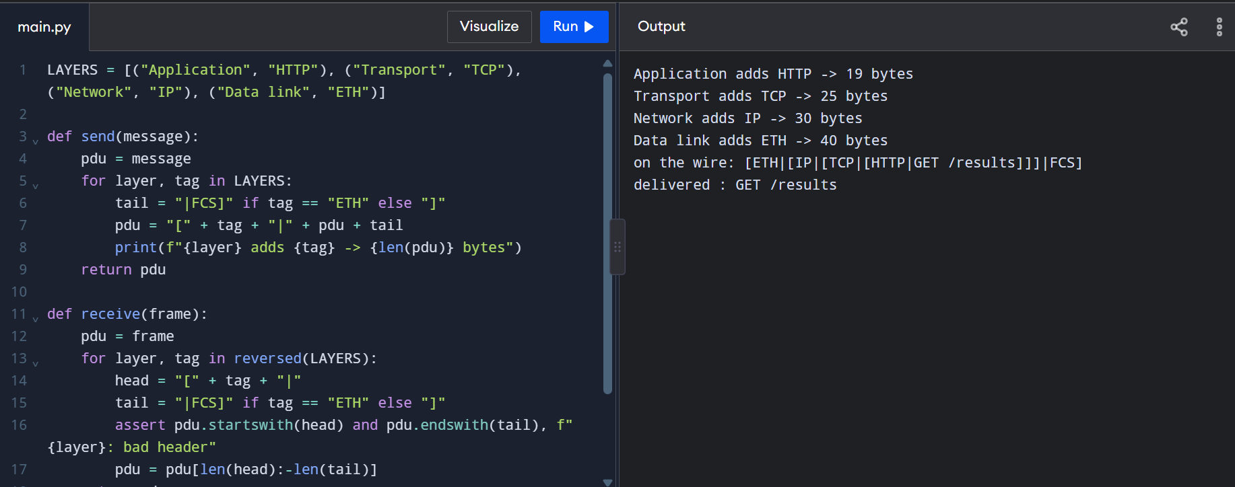

TASK 4 – Choose a Medium for Each Run (There Is a Trap)
Bloom’s Level: K5 – Evaluate
The plant has four cable runs: (a) a robot cell next to arc-welding machines, 85 m; (b) the office floor to the shop-floor switch, 140 m; (c) the shop floor to the data centre, 550 m; (d) the plant to the head office, 400 km.
Work out:
- A medium for each run (Cat6 UTP, Cat6A S/FTP, multimode fibre, single-mode fibre, leased line or wireless) with the deciding reason
- Which run cannot use copper Ethernet at all, and why (look at the distance limits)
- The Shannon capacity of a 250 MHz cable with an SNR of 40 dB and of the same cable near the welders with an SNR of 15 dB – what does the difference mean for the robot cell?
- Why the speed measured on a link is always below the Shannon limit
Solution:
Aim:
To choose suitable transmission media for four distances and evaluate channel capacity under noise.

Objectives:
Match each run to a medium, apply distance limits, calculate Shannon capacity, and assess wireless operation near welding equipment.

Media Selection and Calculations:
a) Robot cell to nearby switch, 85 m beside arc welders: shielded Cat6A S/FTP is a reasonable copper choice within the 100 m Ethernet channel limit; fibre is even more immune to electromagnetic interference where practical. b) Office floor to shop-floor switch, 140 m: fibre, because standard copper Ethernet channel length is normally limited to 100 m. c) Shop floor to data centre, 550 m: multimode fibre where supported by the selected Ethernet optics. d) Plant to head office, 400 km: single-mode fibre through a carrier/leased-line or suitable WAN service; copper Ethernet cannot span this distance. Shannon capacity C = B log₂(1 + SNR), with SNR as a linear ratio. At 40 dB, SNR = 10⁴ = 10,000. C = 250×10⁶ log₂(10,001) ≈ 3.322 Gbps. At 15 dB, SNR = 10^1.5 ≈ 31.62. C = 250×10⁶ log₂(32.62) ≈ 1.257 Gbps. The theoretical capacity falls substantially with noise, and real-time control should not depend on theoretical capacity alone.The measured speed is below Shannon capacity because of modulation/coding choices, protocol overhead, hardware limits, interference, retransmissions and implementation constraints.

Complete the Code – Nyquist and Shannon:
import math
def nyquist(bandwidth_hz, levels):
return 2 * bandwidth_hz * math.log2(levels)
def shannon(bandwidth_hz, snr_db):
snr = 10 ** (snr_db / 10)
return bandwidth_hz * math.log2(1 + snr)
media = [("Telephone line", 3100, 30), ("Cat6 pair", 250e6, 40),
("Wi-Fi 6 channel", 160e6, 25)]
for name, bw, snr in media:
print(f"{name:<16} Shannon limit {shannon(bw, snr) / 1e6:10.2f} Mbps")
print(f"Nyquist, 3,100 Hz with 4 levels: {nyquist(3100, 4) / 1e3:.1f} kbps")For a 3,100 Hz telephone line to carry 56 kbps, required SNR = 2^(56,000/3,100) − 1 ≈ 2.75×10⁵, or about 54.4 dB. This is extremely demanding for a narrow-band telephone channel. Wi-Fi 6 at 160 MHz and 15 dB SNR: C ≈ 160×10⁶ log₂(1 + 31.62) ≈ 805 Mbps. Despite high theoretical capacity, Wi-Fi is not the preferred sole path for 10 ms robot commands near welders because interference, contention and roaming create delay variability.

Result:
Fibre is required for long runs; shielded cable or fibre suits the welding area. The theoretical Shannon limits are approximately 3.322 Gbps at 40 dB and 1.257 Gbps at 15 dB for 250 MHz.

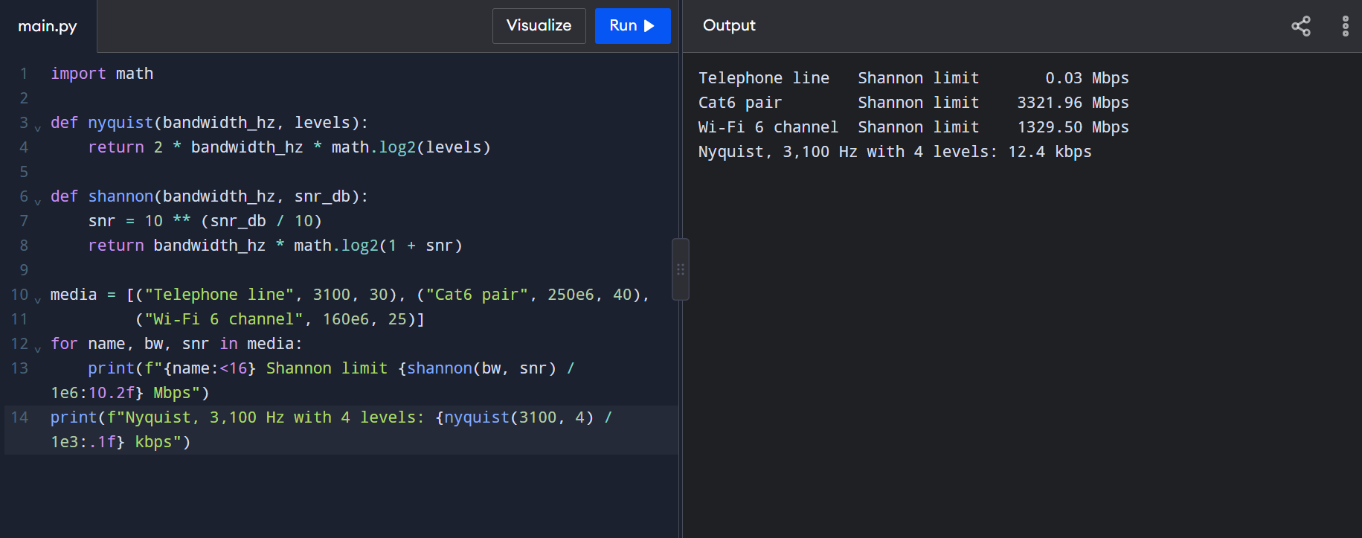
TASK 5 – Wi-Fi 6 or 5G for Moving Equipment
Bloom’s Level: K5 – Evaluate
An AGV travels at 2 m/s along a 1.2 km route. Wi-Fi access points are 30 m apart, and a Wi-Fi hand-over takes about 150 ms. A private 5G cell covers 300 m, and a 5G hand-over takes about 20 ms. AGV commands have a 10 ms deadline.
Work out:
- The number of hand-overs per trip for Wi-Fi and for 5G, and the total time per trip during which the AGV is not reachable
- Which of the three 5G service types (eMBB, URLLC, mMTC) the AGVs, the cameras and the sensors each need
- Where Bluetooth, Zigbee or LoRa would be a better choice than Wi-Fi or 5G in the plant
- Whether Wi-Fi 6 with fast roaming (802.11r) could meet the deadline – and what remains risky
Solution:
Aim:
To compare Wi-Fi and private 5G handovers for autonomous guided vehicles (AGVs).

Objectives:
Calculate handover interruptions, match devices to 5G service types, select low-power alternatives, and evaluate fast roaming.

Calculations and Analysis:
For a 1.2 km route with access points 30 m apart, there are about 40 Wi-Fi coverage intervals and approximately 39 transitions after the initial connection. Interruption ≈ 39 × 150 ms = 5,850 ms = 5.85 s per trip. For 300 m 5G cells, the route spans 4 cells and has about 3 transitions. Interruption ≈ 3 × 20 ms = 60 ms per trip. These aggregate interruptions do not mean each handover itself meets the 10 ms command deadline; a 20 ms interruption is still longer than the deadline.
Service mapping: AGV/robot control—URLLC; CCTV video—eMBB; large numbers of low-rate sensors—mMTC. Bluetooth suits very short-range peripherals and maintenance devices; Zigbee suits low-power local sensor networks; LoRa/LoRaWAN suits sparse, low-rate, long-range telemetry—not high-rate, deadline-critical control.
Wi-Fi 6 fast roaming (802.11r) can reduce handover delay, but contention, interference, roaming failures and variable latency remain risks. It must be tested against the 10 ms deadline rather than assumed reliable.

Alternative Concept Analysis:
600 sensors × 50 bytes/s × 8 = 240,000 bit/s = 240 kbps. One LoRa gateway with an approximate capacity of 5 kbps cannot carry this offered load: 240/5 = 48 times its capacity. Only a subset of sensors with much lower reporting rates should use LoRaWAN; the stated 50-byte/s sensors should remain on a higher-capacity network or be aggregated/reported less frequently.

Result:
Private 5G has fewer handovers than the proposed Wi-Fi layout, but its stated 20 ms handover still exceeds the 10 ms command deadline. Use engineered URLLC with tested continuity and keep high-volume CCTV on wired Ethernet/fibre where possible.

TASK 6 – Interpret an Ethernet Port Report
Bloom’s Level: K5 – Evaluate
A shop-floor PC is slow. Its network interface reports:
Speed: 100Mb/s Duplex: Half Auto-negotiation: off
Link detected: yes rx_errors: 2381 late_collisions: 412 crc_errors: 1907

Work out:
- What a late collision and a CRC error each mean, and what the combination suggests about the two ends of the link
- The likely cause (a duplex mismatch with a gigabit switch port set to auto) and the exact configuration change on Linux (ethtool) or Windows
- Whether the MAC address 01:00:5e:0a:01:02 belongs to a single device or a group, and what the first three bytes of 3c:52:82:4e:11:07 identify
- Whether jumbo frames (9,000 bytes) would help the CCTV storage server, and what must also change for them to work
Solution:
Aim:
To diagnose Ethernet errors and recommend corrective configuration.

Objectives:
Explain late collisions and CRC errors, identify a likely duplex mismatch, interpret MAC address types and evaluate jumbo frames.

Analysis:
The port reports 100 Mb/s, half duplex, auto-negotiation off, 2,381 receive errors, 412 late collisions and 1,907 CRC errors. Late collisions occur after the normal collision window and often indicate a duplex mismatch or physical-layer/cabling problem. CRC errors mean received frames fail the frame check sequence. Together, the counters suggest a link configuration mismatch and/or cable/interference problems.
Set both ends consistently. Prefer auto-negotiation enabled at both the PC and switch if supported. On Linux, identify the interface with `ip link`, then use `sudo ethtool -s eth0 autoneg on` (replace eth0 with the actual interface) and verify with `ethtool eth0`. If the link must be forced, speed and duplex must match at both ends; do not force one side while leaving the other side at auto.
MAC 01:00:5e:0a:01:02 is an IPv4 multicast MAC address, representing a group rather than one individual unicast device. The first three bytes 3c:52:82 are the OUI prefix, which identifies the registered manufacturer/assignment; the exact vendor should be confirmed with an OUI database.
Jumbo frames of about 9,000 bytes may improve throughput for a CCTV storage server by reducing per-packet overhead, but every device along the path (server NIC, switches, router if traversed, and interfaces) must support and be configured for the same MTU. Otherwise fragmentation or dropped frames can occur.

Alternative Concept Analysis:
A redundant industrial ring can reroute traffic after a cable cut; recovery depends on the ring protocol and equipment, and should be verified against its stated recovery time. A star has simple fault isolation, but a cut in a single access link disconnects the devices beyond that link; a cut in the central uplink can isolate an entire branch. A ring can preserve connectivity after one link failure if the ring protocol converges, while a star requires a redundant path to offer equivalent resilience.

Result:
The port counters point to a likely duplex or physical link problem. Configure both ends consistently, verify the link and cabling, and use jumbo frames only when end-to-end MTU support is confirmed.

TASK 7 – Will the Receiver Notice the Error?
Bloom’s Level: K5 – Evaluate
Frames between two shop-floor switches are protected by a CRC with generator 1011 (x³ + x + 1).
Work out:
- The CRC bits for the data 1101011011, by hand (show the division)
- Whether a received frame 1101011011101 is accepted or rejected
- The longest burst error this generator is certain to detect, and an error pattern it cannot detect
- The two-dimensional parity of a 4 × 4 block of your choice, and a 4-bit error pattern that two-dimensional parity misses
- The Internet checksum of the four 16-bit words 4500, 0073, 0000, 4000 (hexadecimal)
Solution:
Aim:
To evaluate CRC, parity and Internet checksum methods for detecting transmission errors.

Objectives:
Perform modulo-2 division, test a received frame, explain burst-error detection, calculate two-dimensional parity and compute the checksum.

Calculations and Analysis:
Generator 1011 has degree 3. Append three zero bits to data 1101011011 to obtain 1101011011000. Modulo-2 division by 1011 gives remainder 100, so the transmitted codeword is 1101011011100. The received frame 1101011011101 has a non-zero remainder and is rejected. A degree-3 CRC detects every burst error of length 3 bits or less. An error polynomial that is a multiple of the generator can be undetected; for example, the aligned error pattern 1011000 represents generator 1011 multiplied by x³, so its remainder is zero. Example 4×4 data block: 1 0 1 1 / 0 1 0 1 / 1 1 0 0 / 0 0 1 1. Add one even-parity bit to each row and column. Row parity bits are 1, 0, 0, 0; column parity bits are 0, 0, 0, 1 (include a final corner bit chosen to make parity of parity bits even). Two-dimensional parity can miss a rectangular four-bit pattern: flipping the four corners of a rectangle changes each affected row and column by two bits, leaving their even parity unchanged.
Internet checksum: add the 16-bit words 0x4500 + 0x0073 + 0x0000 + 0x4000 = 0x8573. One’s complement gives 0x7A8C.
Complete the Code – CRC:
def mod2_div(dividend, divisor):
rem = list(dividend)
for i in range(len(dividend) - len(divisor) + 1):
if rem[i] == "1":
for j in range(len(divisor)):
rem[i + j] = "0" if rem[i + j] == divisor[j] else "1"
return "".join(rem[-(len(divisor) - 1):])
def encode(data, gen):
crc = mod2_div(data + "0" * (len(gen) - 1), gen)
return data + crc
def check(frame, gen):
return set(mod2_div(frame, gen)) == {"0"}
GEN = "1011"
frame = encode("1101011011", GEN)
print("transmitted:", frame)
print("no error :", check(frame, GEN))
bad = frame[:4] + ("1" if frame[4] == "0" else "0") + frame[5:]
print("1-bit error:", check(bad, GEN))
burst = frame[:2] + "".join("1" if b == "0" else "0" for b in frame[2:5]) + frame[5:]
print("3-bit burst:", check(burst, GEN))
Alternative Concept Analysis:
Even parity detects any odd number of bit flips, including many single-bit errors, but misses every even-numbered error pattern such as a two-bit error. CRC-3 detects all one-bit and two-bit errors for this frame length and all bursts of length ≤3, but can miss some longer patterns divisible by 1011. Example: two flipped bits 00000011 (polynomial x+1) are not divisible by 1011 and are detected by CRC; a four-bit rectangular pattern may be missed by two-dimensional parity. CRC and parity have different guarantees and neither corrects the data by itself.
Result:
The CRC remainder is 100, the valid frame is 1101011011100, and the Internet checksum is 0x7A8C. CRC generally provides stronger error detection than a single parity bit.
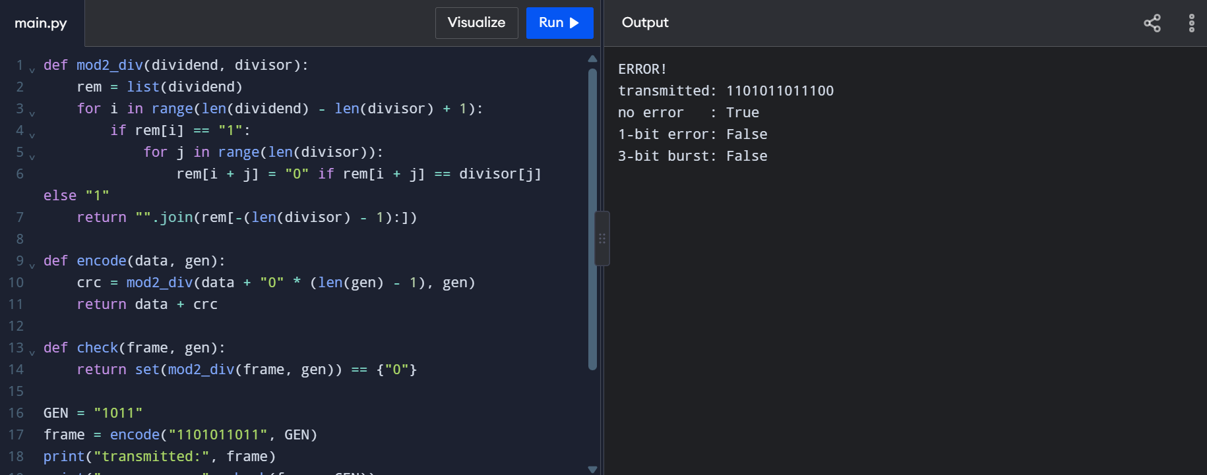

TASK 8 – Correct the Error or Ask Again?
Bloom’s Level: K5 – Evaluate
A vibration sensor sends 16-bit readings over a noisy radio link where retransmission takes 40 ms.
Work out:
- The number of Hamming check bits needed for a 16-bit word (use 2ʳ ≥ m + r + 1) and the overhead percentage
- The minimum Hamming distance of the code {00000, 01011, 10101, 11110}, and how many errors it can detect and correct
- The corrected data when the Hamming(7,4) codeword 0110011 arrives as 0110111
- Whether forward error correction or retransmission (ARQ) suits this link, and why video streaming and 5G use FEC
Solution:
Aim:
Compare forward error correction (FEC) and retransmission (ARQ) for a noisy sensor link.
Objectives: Calculate Hamming check bits and code distance; decode a received word; compare FEC and ARQ.
Calculations and Analysis:
• For m = 16 data bits, choose r such that 2n ≥ m + r + 1. r = 4 is insufficient (16 < 21); r = 5 works (32 ≥ 22). Five
check bits are needed; total = 21 bits. Check-bit overhead is 5/21 × 100 = 23.81% of transmitted bits.
• For codewords {00000, 01011, 10101, 11110}, minimum Hamming distance is 3. It can detect up to 2 bit errors or
correct 1 bit error.
• Hamming(7,4) word 0110011 received as 0110111 has syndrome position 5. Correcting bit 5 restores 0110011; data
positions 3, 5, 6 and 7 give 1011.
Python Program:
def encode(d):
p1 = d[0] ^ d[1] ^ d[3]
p2 = d[0] ^ d[2] ^ d[3]
p3 = d[1] ^ d[2] ^ d[3]
return [p1, p2, d[0], p3, d[1], d[2], d[3]]
def decode(c):
s1 = c[0] ^ c[2] ^ c[4] ^ c[6]
s2 = c[1] ^ c[2] ^ c[5] ^ c[6]
s3 = c[3] ^ c[4] ^ c[5] ^ c[6]
pos = s1 + 2*s2 + 4*s3
if pos:
c[pos-1] ^= 1
return pos, [c[2], c[4], c[5], c[6]]
word = encode([1, 0, 1, 1])
received = word[:]
received[4] ^= 1
position, data = decode(received)
print("codeword:", "".join(map(str, word)))
print("corrected position:", position)
print("data:", "".join(map(str, data)))
Alternative Concept Analysis:
For ARQ, expected transmissions per successful reading ≈ 1/(1−0.0159) = 1.0162. With a 40 ms retransmission wait, expected extra waiting time is about 0.65 ms per successful reading.
Result:
Five check bits are required; minimum code distance is 3; the received Hamming word is corrected to data 1011. FEC is useful for time-sensitive sensor traffic
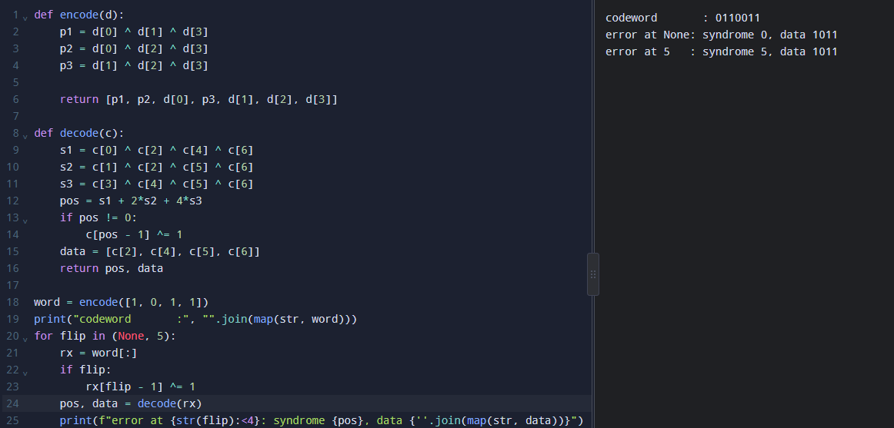
TASK 9 – How Big Must the Window Be?
Bloom’s Level: K5 – Evaluate
The head-office link is 400 km of fibre at 1 Gbps; frames are 1,500 bytes; light travels at 2 × 10⁸ m/s in fibre.
Work out:
- The transmission time, the propagation time and the ratio a = propagation / transmission
- The link utilisation with stop-and-wait ARQ – and what it means in Mbps
- The smallest window that keeps the link fully used, and the number of sequence-number bits needed for Go-Back-N and for Selective Repeat with that window
- Which of the two ARQ protocols resends fewer frames after one loss, and what it costs the receiver
- How HDLC or PPP frames mark the start and end of a frame
Solution:
Aim:
Calculate link utilisation and sliding-window requirements for a long-distance fibre link.
Objectives:
Calculate transmission and propagation times; evaluate stop-and-wait; find the required window compare Go-Back-N and Selective Repeat.
Calculations and Analysis:
• Frame size = 1,500 × 8 = 12,000 bits. Transmission time = 12,000/10n = 12 μs.
• One-way propagation = 400,000/(2×10n) = 2 ms. a = propagation/transmission = 2 ms/0.012 ms = 166.67.
• Stop-and-wait utilisation U = 1/(1+2a) = 1/334.33 = 0.299%. Throughput ≈ 2.99 Mbps on a 1 Gbps link.
• Full utilisation requires W ≥ 1+2a = 334.33, so minimum integer window is 335 frames.
• Go-Back-N requires W ≤ 2n−1; 9 sequence bits allow up to 511 frames. Selective Repeat requires W ≤ 2^(m−1); 10
bits are needed for a window of 335.
• Selective Repeat retransmits only lost/errored frames, but needs more receiver buffering and sequence tracking.
HDLC uses flag 01111110; PPP uses the HDLC-like flag 0x7E.
Python Program:
def utilisation(frame_bits, rate_bps, distance_m, window, speed=2e8):
tx = frame_bits / rate_bps
prop = distance_m / speed
a = prop / tx
return min(1.0, window / (1 + 2*a)), a
links = [("Campus LAN", 1e9, 200),
("City fibre", 1e9, 50_000),
("Satellite", 10e6, 36_000_000)]
for name, rate, dist in links:
u1, a = utilisation(12_000, rate, dist, 1)
u7, _ = utilisation(12_000, rate, dist, 7)
u127, _ = utilisation(12_000, rate, dist, 127)
print(name, "a =", round(a, 2), "SW =", round(u1*100, 2),
"% W=7 =", round(u7*100, 2), "% W=127 =", round(u127*100, 2), "%")
Alternative Concept Analysis:
A 64-frame Selective Repeat receiver needs at least 64 × 1,500 = 96,000 bytes (about 96 kB) of frame buffering,
excluding implementation overhead.

Result:
Stop-and-wait provides about 0.30% utilisation. A 335-frame window is required for full utilisation
under the simplified assumptions; Selective Repeat with 64 frames reaches about 19.14% utilisation (about 191
Mbps)

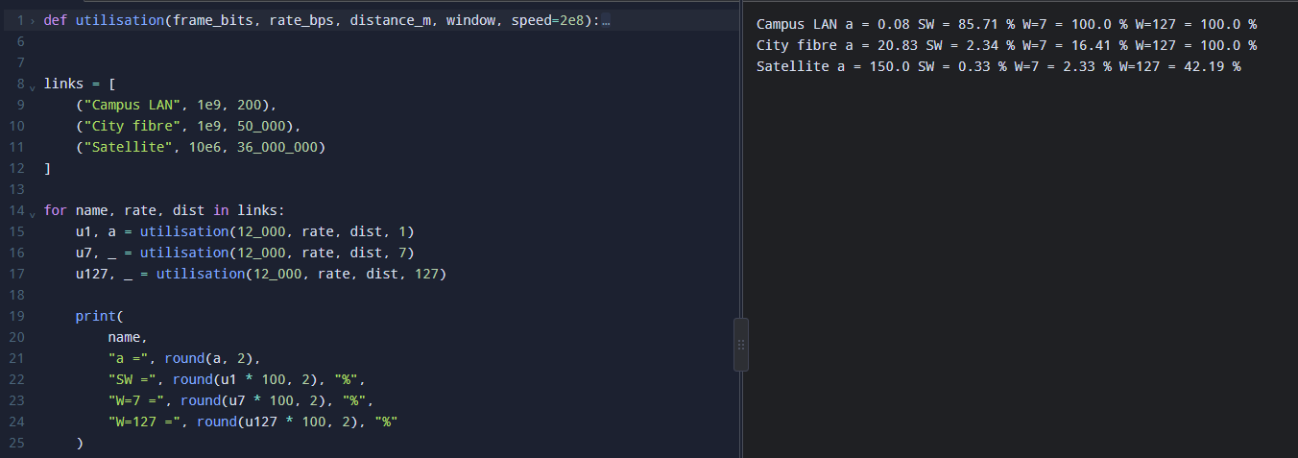
TASK 10 – Find Where the Delay Comes From
Bloom’s Level: K5 – Evaluate
A traceroute from the plant to the head-office server gives:
1 10.10.1.1 0.6 ms 0.5 ms 0.6 ms
2 100.64.0.1 3.1 ms 2.9 ms 3.4 ms
3 172.31.4.9 4.0 ms 38.2ms 4.2 ms
4 103.21.8.17 11.8 ms 11.5ms 12.1ms
5 * * *
6 10.200.0.10 12.6 ms 12.4ms 12.9ms

Work out:
- The propagation delay you would expect for 400 km of fibre, and how much of the measured delay it explains
- Why hop 3 shows one value of 38.2 ms, and why hop 5 shows only stars – are they faults?
- Which hop adds the most delay
- Your own traceroute, ping and Wireshark capture of a real connection, with the headers of each layer identified
Solution:
Aim:
Interpret traceroute measurements and distinguish propagation delay from variable network delay.

Objectives:
Estimate fibre propagation delay; analyse outlier and non-responsive hops; identify the largest observed increase; describe diagnostic evidence.
Calculations and Analysis:
• For 400 km fibre, one-way propagation = 400,000/(2×10n) = 2 ms. Round-trip propagation lower bound ≈ 4 ms,
excluding processing and routing.
• Compared with a final typical RTT of 12.6 ms, propagation accounts for about 4/12.6 × 100 = 31.7%.
• Hop 3 values 4.0, 38.2 and 4.2 ms contain one spike; this may be transient queueing, processing delay or ICMP rate limiting, not necessarily persistent forwarding delay.
• Hop 5 stars mean probes did not receive a reply within timeout. Since hop 6 responds, this alone does not prove forwarding failure; routers may filter or rate-limit ICMP.
• Typical RTT rises from about 4 ms at hop 3 to 11.8 ms at hop 4, an increase of roughly 7.8 ms. Traceroute RTTs to successive hops are not perfectly additive.
• Useful evidence: `tracert <host>` on Windows or `traceroute <host>` on Linux; `ping -n 10 <host>` or `ping -c 10 <host>`; Wireshark capture of Ethernet, IP and TCP/UDP headers.
Alternative Concept Analysis:
SNMP interface counters can show sustained errors, drops, utilisation and link changes; NetFlow can identify heavy traffic sources. They provide broader ongoing visibility than occasional ping/traceroute, but require monitoring infrastructure.
Result:
Fibre propagation explains about 4 ms of the 12.6 ms round-trip delay. The spike and non-responsive hop require repeated tests and supporting interface evidence before diagnosing a fault.

TASK 11 – Defend the Network Design 4 Marks
Bloom’s Level: K5 – Evaluate
Recommend the network design for the plant.
Work out:
- The medium, wireless technology and Ethernet settings for each area
- The error-control and flow-control method for each link, with the calculation that justifies it
- The two biggest risks that remain in your design
- Whether your design still works for five plants
Solution:
Aim:
Recommend a scalable and reliable network design for the smart manufacturing plant.

Objectives:
Select media and wireless technologies by area; select error/flow control; identify risks; assess growth to five plants.
Calculations and Analysis:
• Robot cells/fixed controllers: industrial Ethernet over shielded Cat6A S/FTP for short runs, or fibre in high-noise areas. Use a dedicated VLAN, QoS priority and industrial protocols with bounded latency.
• Shop-floor backbone/data centre: fibre between switches/buildings. Use single-mode fibre or carrier WAN for the 400 km head-office link. Original eight-line load is 1,265.92 Mbps, so a suitably engineered higher-capacity backbone such as 10 GbE is appropriate, with headroom.
• CCTV: wired Ethernet/fibre to storage, local recording and motion-triggered upload. At 5% average upload, eight-line calculated load drops to 536.32 Mbps.
• Office users: Wi-Fi 6 for mobility and switched Ethernet for fixed workstations. Separate office and industrial traffic using VLANs and firewall rules.
• Low-rate sensors may use Zigbee/LoRaWAN only if capacity and delay fit. The given 600 sensors at 50 bytes/s need 240 kbps, too much for one 5 kbps LoRa gateway.
• Use Ethernet FCS/CRC for frame error detection; TCP/ARQ for office/file transfers; suitable industrial sequence/timeout mechanisms and redundancy for control. Sliding windows are needed on long-delay WAN links.
• Risks: radio interference/latency variation affecting mobile control; congestion and single points of failure. Mitigate with wired control where practical, tested private 5G, QoS, redundant fibre, monitoring and capacity planning.
• For five plants, use routed site-to-site WAN/SD-WAN or carrier connectivity, scalable addressing, consistent VLAN/security templates and central monitoring. Avoid one flat Layer-2 broadcast domain across all plants.
Alternative Concept Analysis:
Private 5G is useful for AGVs, but fixed CCTV and backbone traffic should remain on wired Ethernet/fibre where possible. Validate end-to-end latency, reliability, spectrum, interference and handover behaviour.
Result:
A hybrid network—industrial wired Ethernet/fibre for fixed and high-volume traffic, Wi-Fi 6 for office access, and private 5G URLLC for mobile AGVs—balances capacity, latency, reliability and cost.

TASK 12 – Re-evaluate and Adapt the Design
Bloom’s Level: K5 – Evaluate
Changed Requirement
The company adds a private 5G network on the shop floor and 50 AGVs that move parts between lines and must never miss a command.
Re-evaluate your original design. You may RETAIN → MODIFY → or REDESIGN your original solution.

Aim:
To reassess the original plant network after adding private 5G and 50 AGVs, and justify whether the design should be
retained, modified or redesigned.
Objectives:
• Identify affected media and recalculate traffic with 50 AGVs.
• Test Wi-Fi and 5G handover against the 10 ms deadline.
• Propose a revised architecture for robots, AGVs, offices and cameras.
• Defend the decision using numerical evidence and trade-offs.
Analysis:
A. Impact analysis and traffic
• The change affects wireless coverage, mobility management, QoS, addressing, security, edge services and error-control design. Fixed robot controllers and cameras can remain wired; AGVs require mobile radio coverage and resilient handover.
• The assignment does not state the AGV command size or frequency. For a transparent estimate only, assume each AGV uses the same traffic profile as a robot controller: 200 bytes every 2 ms. Per AGV = 200 × 8 × 500 = 0.8 Mbps. For 50 AGVs = 40 Mbps additional traffic.
• Using the Task 1 eight-line plant total of 1,265.92 Mbps, adding 40 Mbps gives 1,305.92 Mbps (1.306 Gbps). This assumes the 50 AGVs are additional plant-wide devices and their traffic is additional to the original robot-controller traffic. If the AGV command profile differs, recalculate using its measured packet size and rate.
B. Test the original design
• Wi-Fi: approximately 39 handovers per 1.2 km route × 150 ms = 5.85 seconds of estimated unreachability. This cannot meet a 10 ms command deadline.
• 5G: approximately 3 handovers × 20 ms = 60 ms total estimated unreachability per trip. This is a major improvement over Wi-Fi, but an individual 20 ms handover interruption still exceeds the 10 ms deadline. A 5G label alone does not prove the control requirement is met.
C. Adaptation / redesign
• Decision: MODIFY the original hybrid design. Deploy private 5G URLLC for the 50 moving AGVs, while retaining wired industrial Ethernet for fixed robot controllers and fixed cameras, Wi-Fi 6 for office users, and fibre for the plant backbone.
• Engineer overlapping 5G coverage, make-before-break or dual connectivity where supported, redundant radio/core paths, local edge control and a safe autonomous fallback. Validate worst-case latency, packet loss, jitter and handover interruption under full load. Keep emergency-stop and safety functions on appropriately certified safety systems rather
than depending solely on best-effort wireless delivery.
• Prioritise robot and AGV control traffic; isolate it from CCTV and office traffic using VLANs, QoS and traffic engineering. Keep video recording local and send clips or selected streams across the backbone.
D. Evidence-based defence
• The baseline eight-line demand is 1.266 Gbps, rising to approximately 1.306 Gbps under the stated AGV traffic assumption. The continuous CCTV alternative reduces the original estimate to 536.32 Mbps, leaving more backbone headroom, although actual peak and burst measurements are required.
• Wi-Fi's estimated 5.85 s handover unreachability is unsuitable for 10 ms commands. 5G's estimated 60 ms per route is much lower, but its 20 ms individual handover remains above the deadline. The design therefore requires continuity mechanisms and real acceptance tests rather than relying on nominal coverage alone.
• Trade-off: private 5G improves mobility and centralised wireless management but adds radio planning, spectrum,
core-network, security and operational complexity. Wired Ethernet/fibre costs installation effort but gives predictable fixed
links and high capacity. A hybrid approach balances mobility with deterministic fixed connectivity

Alternative Concept Analysis :
The decision is supported by traffic totals of 1,265.92 Mbps originally and 1,305.92 Mbps after the illustrative AGV addition. Local CCTV recording reduces the revised total to 576.32 Mbps. 5G reduces estimated handover interruption but does not by itself satisfy a 10 ms deadline. The trade-off is higher cost and management complexity in exchange for mobility, capacity and resilience.
Result:
The original design should be modified, not retained unchanged. A hybrid wired/fibre + private 5G + office Wi-Fi 6 design best addresses the changed requirements, provided the 10 ms AGV deadline is verified by realistic end-to-end testing.

